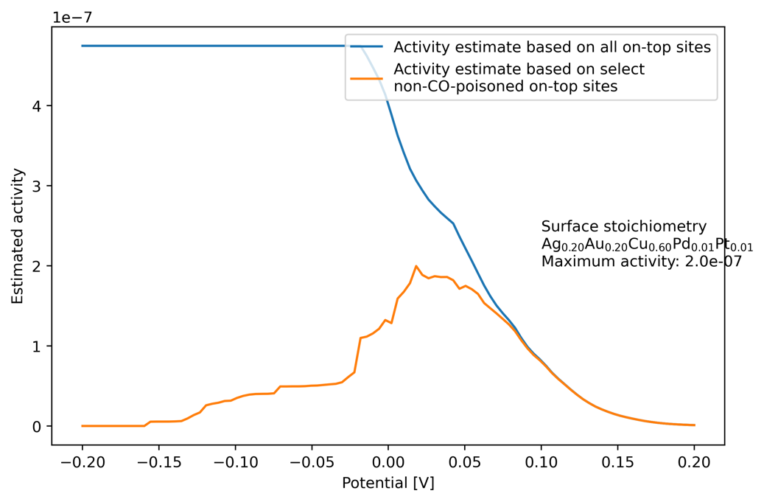

Figure 17 - The estimated activities based on two different calculations. Using all COOH binding energies (blue) and using only the COOH binding energies from on-top sites, which does not have a neighbouring hollow site, where H has a negative binding energy. These sites are assumed to be CO-poisoned due to the COOH+H disproportionation reaction, and are counted as a 0 in the activity sum.

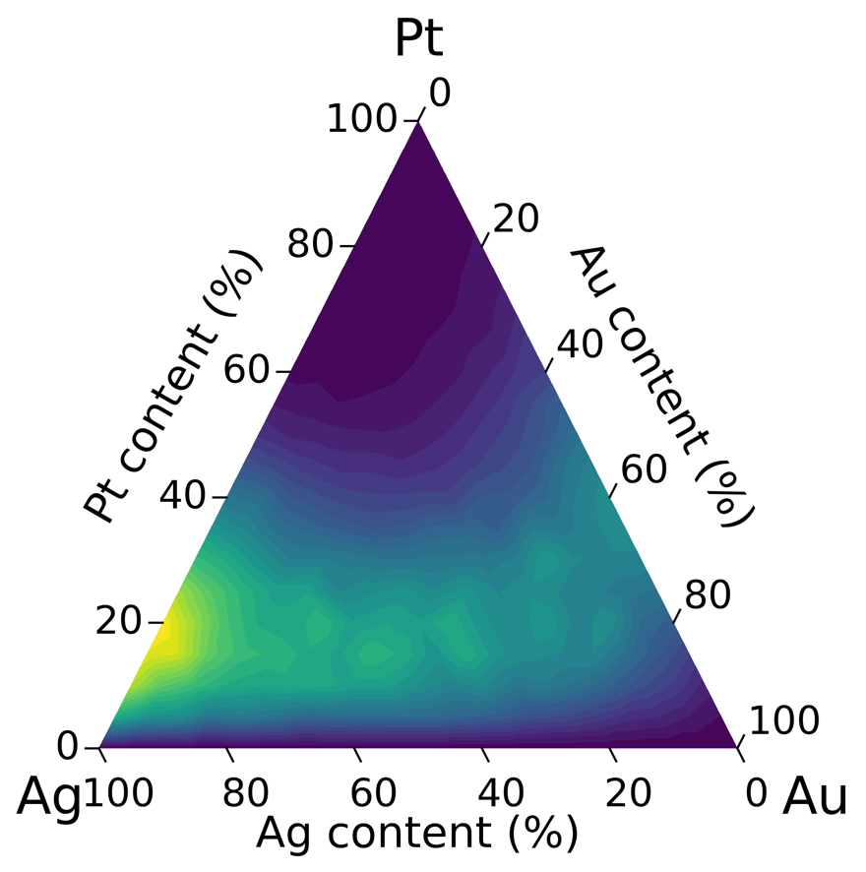

Figure 19 – Ternary activity plot with 5% molar fractions of platinum, silver and gold. The highest activity found was 5.2*10e-6 at the composition Pt0.8Ag0.2 at the potential (eU) of 0.07 V vs RHE.

In figure 17, the metals platinum, silver and gold has been chosen, with all 5% molar fractions

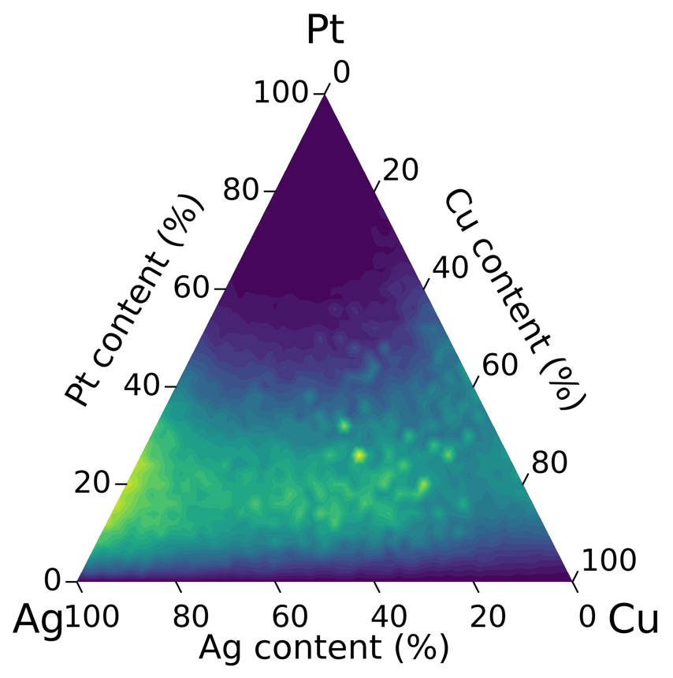

Figure 20 - figure

Fedt

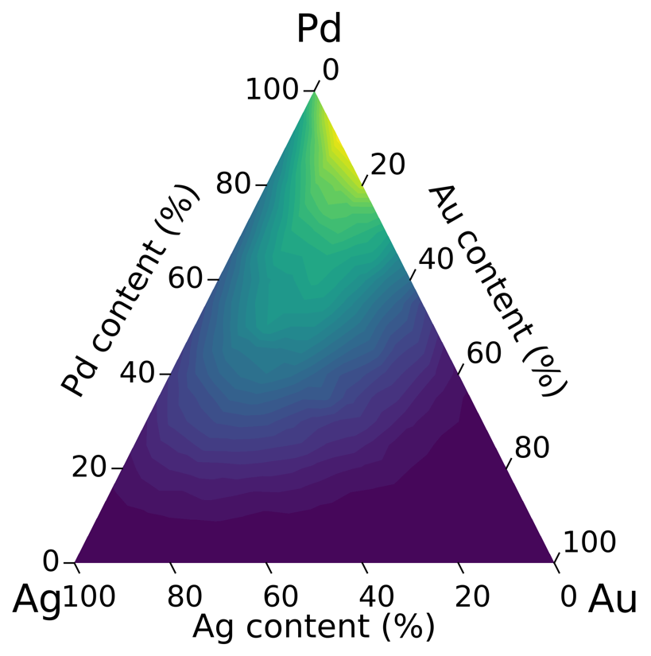

Figure 21 - Ternary activity plot based on 5% molar fractions of palladium, gold, and silver. The optimal composition when restricted to the three selected metals is Pd0.9Au0.1 with a comparably low activity of 2.4*10e-10 at a potential (eU) of 0.2 V vs RHE.

Tekst

**DFT calculations**

***Slabs for testing CO-OH slide reaction***

what was the conclusion on this? Seemed unreasonable?

I guess basically the story is: FA has a high theoretical efficiency, but is plagued by very low activity until the voltage has been increased to clean the surface, pointing towards a

Single-site anode catalysts have had success (refx3), so this points towards a hypothesis that is xx, hence it should be investigated how and why and if it can be replicated theoretically and computationally to learn more about it and perhaps peep into optimizations.

***Bayesian optimization***

Math explanation, practical – Explain in introduction or methods?

In figure x, two activity estimation routines are compared on varying potentials (eU) for the same simulated HEA surface. The simplest routine, shown in blue, involves just applying equation x to all binding energies of COOH on on-top sites of the simulated surface. This activity increases as the potential (eU) decreases from 0.2 V and achieves the maximum activity at the optimal potential calculated to -0.17 V. However, formic acid oxidation is assumed to be held back by CO oxidation, so the activity estimation function needs to account for that in order to accurately predict FAOR performance. This routine is shown in orange, and as expected shows an increasing activity when the potential decreases from 0.2 V, but then is decreases by hydrogen UPD, which starts poisoning on-top sites around 0.1 V and has poisoned every site around 0.16 V. A maximum is found in the middle, typically between at small positive potentials around 0.07 V, depending on the surfaces ability to deter H adsorbing to neighbouring on-top sites. A theoretical surface with large positive binding energies for H in hollow sites and low COOH binding energies on on-top sites would be able to be most active at a lower potential, which would improve the efficiency.

A brute-force search approach has been used on the stoichiometries / molar fractions to find the most active composition of the surface. Molar fractions of 5% intervals was made for all five metals, leading to 10626 compositions, and from each composition a 200 by 200 by 3 surface was simulated, the binding energies of COOH and H predicted by the appropriate model and the activity estimated.

Based on the COOH binding energies as shown in figure 8, it’s known that either platinum or palladium is needed for formic acid oxidation, but pure platinum or palladium surfaces might not be optimal anode catalysts due to CO poisoning. Hence, examining the impact of silver, gold, and copper along with platinum and/or palladium on the formic acid oxidation activity is of interest.

When testing all 5% molar fraction the highest activity is found at this stoichiometry at this potential.

With ternary activity plots, plotting the activity of all possible molar fractions of a trimetal is possible.

The hunt is therefore on for an atom on the periodic table, which fulfils the criteria for an optimal catalyst.

Scaling relations might be a hindrance

COOH needs to bind way stronger, but that is correlated with a stronger H binding in general. Can this be circumvented with single-sites or will H just move on-top and block?

The optimal anode potential sets some pretty rough criteria. Also, the activity increases at higher potentials and the efficiency per HCOOH increases with the open-circuit voltage as

De forskellige potentialer vs RHE

CO oxidation and CO creation.

Note: Nifty that I have neighbour DFT data that might be able to show the same thing.

Note: Go into specifics with different reaction pathways? Mention the dentates? Or just show the free energy diagram later and say it doesn’t look feasible? Based on DFT data the energy increases.

Show free energy diagrams – optimal binding energy and perhaps one with voltage that makes them equal in energy? And one with the energies from

Måske vis, at man kan bruge Pt som reference, og så notere bindingsenergier som “den binder så godt her ift. Platin”, og det har man for OH og det dobbelte for O, men der er ikke for COOH og dentaterne. (Eller ligegyldigt måske? Jeg burger det jo ikke)

Kohn-Sham DFT applied to calculate the binding energies of various adsorbates.

Hohenberg-Kohn proved, that electron densities can perfectly describe a quantum system. Two theorems. 1: Unique one-to-one mapping between ground state energy of system and its electron density. 2: A variational principle holds for electron densities; the electron density can be found by minimizing the expectation value of the energy (Jacks sætning) (Det hele skal omskrives en gang ekstra, selvom intet er kopieret direkte)

**Plotting GH vs GCOOH**

Plotting them H vs COOH

Using energy prediction models on simulated surfaces

The optimal achievable U_anode might be found in the region just above the potentials, where both H and COOH is present, even though lower COOH binding energies would be more efficient in terms

Then, the challenge of finding the optimal

Describe the criteria used to judge stochs through their binding energies

Swim ring combinations binding energy plots

|  |  |  |  |  |  |  |  |  |
| --- | --- | --- | --- | --- | --- | --- | --- | --- |
| Fuel | Gravimetric energy density (kWh/kg) | Volumetric energy density (kWh/L) | Max theoretical efficiency | Reaction steps | Price (US$/kg, retail) | Operating temperature (°C) | Storage vessel | Storage pressure |
| FA |  |  |  |  |  |  |  |  |
| H2 |  |  |  |  |  |  |  |  |
| CH3OH |  |  |  |  |  |  |  |  |

The electrical energy released by FAOR per electron can be estimated with the free-energy diagram of the direct pathway, as seen in figure x.

FOAR highest U vs CHE: negative

OER highest U vs CHE: positive

The difference is the V_OC

#If formate binds too weakly, the potential can’t be lowered much, before the binding reaction is no longer favourable, leading to a small open-circuit voltage. If formate binds too strongly, what happens? (Tjek ask Jack).

**Notes for formic acid:**

Already close to CO2 in structure, compare to other species like methanol, ethanol. More effective with fever electron transfers and steps. Plot similar to the one from Jack with energy efficiencies

Methanol has a CO base, while formic acid has a OCO base. Methanol has 4 H. So the methanol oxidation requires a pretty large overpotential, which FAOR doesn’t need. This means the potential optimal decent working potential is lower for FAOR.

# How much energy comes out? Per electron? To calculate the maximum electrical energy

Make a simple figure that shows both methanol and formic acid with the backbone highlighted.

Kilder til HEA:

1. [15]  Z. Y. Lv, X. J. Liu, B. Jia, H. Wang, Y. Wu, and Z. P. Lu. Development of a novel high-entropy alloy with eminent efficiency of degrading azo dye solutions. Scientific Reports, 6(34213), 2016. https://doi.org/10.1038/ srep34213.
2. [16]  Chih-Fang Tsai, Pu-Wei Wu, Pang Lin, Cheun-Guang Chao, and Kung-Yu Yeh. Sputter Deposition of Multi-Element Nanoparticles as Electrocatalysts for Methanol Oxidation. Japanese Journal of Applied Physics, 47(7R):5755, 2008. https://doi.org/10.1143/JJAP.47.5755.

Her er Kohn-Sham-Hohenberg-referencerne:

1. [20]  P. Hohenberg and W. Kohn. Inhomogeneous electron gas. Physical Review, 136(3B):B864–B871, 1964. https://doi.org/10.1103/PhysRev.136.B864.
2. [21]  W. Kohn and L. J. Sham. Self-consistent equations including exchange and correlation effects. Physical Review, 140(4A):A1133–A1138, 1965. https: //doi.org/10.1103/PhysRev.140.A1133.

Estimating the energy barrier of something with some other number

***Overpotentials (Prob done already elsewhere)***

***Cyclic voltammetry***

***Polarization testing***

How are experiments made in electrocatalysis? Polarization testing. Talk about a few experiments, perhaps here mention the CO problem and say “so nice, that I made neighbour DFT data”. Setting voltage manually just on the anode catalyst to see what sits on the surface. Controlling the current, and noting the voltage?

Show U = R * I ? xD And P = U * I

Tuning the fractions (Gjort I Jacks ref 3 på en specific reaktion) in general could fit any reaction, in this work applied to formic acid oxidation.

*poisoning effect and Perturbations*

In this work a “forbredning” of the predicted binding energies is seen when simulating surfaces

(ref: Jack kilde 15 og 16 til brug af HEA I experimenter)

Some differences due to blocking and coverage effects making the last

Achieving the exact optimal adsorption energy of a given species

This work seeks to optimize a reaction, in which the activity of the reaction pathways is dependent on specific requirements to the binding energies of different adsorbates.

*Motivation: Why are HEA’s interesting*

*High-Entropy Alloys (HEAs)*

*Class of materials 2004 paper*

*High configuration entropy*

*tune poisoning effect*

*Perturbations*

*Stability of HEAs* (Learn about it from Jacks thesis and google some more)

Mean-field approximation for coverage

Jack mean-field paper

All elements used have FCC structure

How and why and where do different adsorbates sit?

Show a fcc(111) surface and hollow, on-top, mixed site

presenting the adsorbates (Done in data figure)

Look at Jack’s thesis to perhaps sniff out the relevant topics/theory

***Heterogenous Catalysis***

Diagram: A and B, bonding, AB, reaction, etc.

Activation energy lowered

Arrhenius, reaction rate coupled with activation energy

Sabatier then has a contribution regarding binding energy, getting to the surface vs getting off (diffusion)

And then more complex part about specificity towards direct FAOR, which also depend on binding energies

Show the proof for the best mix: (Move to results?)

Coming up with an input that describes the situation adequately, that a model can fit to

Regression to a real numbered target

Treat dft as known targets. Try to get the regression model to predict DFT calculated binding energies

Small paragraph on machine learning in general. Regression/classification

Unknown function between a list of inputs and an output (structured ml problem)

Gradient-Boosted Decision Tree (GBDT)

How do decision trees work, simple example, some equations, etc. maybe a lil image. Ohh maybe the start of the actual tree from one of my best models:)

Regression

The calculations are based on the projector-augmented wave (PAW) method, where the wave functions are described with plane-waves. (Recap possibly not needed).

Notes:

. Looking at the

The single adsorbates of interest are shown in figure wholepageslabfig and are: H, COOH, CO, OH, O.

The neighbour-adsorbates of interest are: H + COOH, CO + OH

Make a table that shows what type of site they sit in? I gotta explain the site types first. And why they are stabilized at surfaces, besides just “energetically favourable”.s

A boring table with the number of sites, etc.?

|  |  |  |  |  |  |  |
| --- | --- | --- | --- | --- | --- | --- |
| **Adsorbate** | COOH | H | CO | OH | O | H+COOH |
| **Site-type** | On-top | Hollow | On-top | On-top | Hollow | Neighbour on-top and hollow |

Explain why these were made and what they are good for

Slabs for estimating H+COOH neighbor interactions

#Maybe I should have made CO+O (I have CO+OH slabs) lmao. To get a more accurate assessment of when O would adsorb next to it. But the most important thing is that CO doesn’t happen at all, so it’s not critical – move to future work haha

Mimics single-sites

Slabs for estimating swim ring efficiency

, because as seen in both pure metal slabs and HEA slabs, the sites with Pt and Pd bind COOH and H stronger than Cu, Au, Ag.

An example is the binding energy from the adsorption reaction of COOH from HCOOH:

$$HCOOH \left(aq\right)+ slab→{}_{ }^{*}{COOH}+(H^{+}+e^{-})$$

With the binding energy elucidated from DFT calculations on slabs and single molecules:

$$ΔE_{}^{DFT}=$$

Show the calculations here like the ones I drew in ppt: *COOH minus * minus COOH from dft as well

(In the plot by alexander these are shown)

. (Tjek: Så få nævnt ren Pt nu)

NOTE: add, that these borders are for even steven HEAs.

OH and O:

Show calculations, corrections – skal der nogen ekstra corrections med der?

Also Bagger article showed the activity of FAOR increasing significantly around

This would make sense with a potential around 0.25 eV

Thermal corrections for the relevant species have been estimated by Chan et. al., and gives the following correction constants:

|  |  |  |  |  |  |
| --- | --- | --- | --- | --- | --- |
| Species | $${}_{ }^{*}H+{}_{ }^{*}{COOH}$$ | $${}_{ }^{*}H$$ | $${}_{ }^{*}{COOH}$$ | $${}_{ }^{*}{OH}$$ | $${}_{ }^{*}O$$ |
| $$C_{correction} [eV]$$ | $$0.74$$ | $$0.20$$ | $$0.29$$ | $$0.315$$ | $$0.03$$ |

The correction constant for COOH

$$ΔG_{{}_{ }^{*}{COOH}}=ΔE_{{}_{ }^{*}{COOH}}+0.495$$

These correction constants (both based on CO2+H2 and HCOOH) predicts that COOH wouldn’t bind (Or only at high voltages? But then CO poisoning wouldn’t be a problem)

Corrections for COOH and H are similar to the ones used in A. Bagger article. They are based on calculated thermal corrections from the BEEF-vdw functional. The corrections should in theory be identical across functionals.

Put in formulas from the notes and explain

Basic adding and subtraction stuff – account for all atoms, leave the binding energy.

Transform from electric DFT energies to Gibbs free energies with Chan numbers.

Surface slabs -> Feature vectors -> Input

DFT calculations -> Binding energies -> Target

Træn indtil konvergens

Tjek: Kig lige på den store data-figur og få skrevet max 10-15 linjer om det her.

, and

General task

Surface to trainable parameters -> Features

Same adsorbate – Both HEA and SWR (SS) data combined. Separate test/val/train split

On-top

Hollow

Mixed-site (combined vector, subtract each adsorbate)

Given energies

and all the equations and figures of them would be nice

Lige nævn XGBoost en gang?

The optimal composition is the composition, that leads to best FAOR performance. The two most important measurable parameters are the overpotential (The open-circuit voltage maybe?) needed to make FAOR happen and the current

Tjek: what about activity? Explain the tradeoff between activity and open-curcuit voltage and hence, efficiency per molecule

Optimally, FAOR would happen as early as possible, at no overpotential, and have a large per-site current. Currently, the FAOR happens at an overpotential, due to surface sites not having the optimal binding energy for *COOH. The per-site current is, in the literature (Kilde: Alexander and others), assumed to be

As seen in alexander, they needed to go to

Composition space

This project will

In the cases where the optimal compositions seems to be comprised of 3 elements,

How much can CO-poisoning be circumvented with tuned HEA on fcc(111) facet.

3 ele

Explain overpotential

Explain Efficiency per molecule formic acid.

The per-site activity of the two-step reaction (direct FAOR) is modeled with the equation:

because the aim of the work is to discover HEA catalysts that circumvent CO-poisoning and with the volcano method,

Only if the COOH binds even better than that will the reaction not be favoured and go uphill

Reaction window: COOH binding energies are allowed to be between 0 and -0.34 at = potential. CO2+H2 energi lowers with 2 eU, faster than COOH at 1eU.

Another possibility is using a sim

Two possibilities, using the activity estimation formula from OER and a simpler method counting the active non-poisoned sites.

We are interested in a descriptor that accounts for CO-poisoning clearly, and with the OER-based activity measure the potential makes a much bigger impact than the tuning of the surface, especially at low potentials.

The FAOR performance is based on the activity on the on-top sites.

The activity on an on-top site is assumed to be 0, if H is adsorbed onto a neighbouring hollow site, assuming that the disproportionation reaction producing CO takes place.

Then, one can choose between using the

The activity estimation has the following procedure, where the activity of each on-top site is estimated. (A potential is given? Or determined by the COOH binding energies?)

* Check if any of the neighbouring hollow sites would adsorb H
  + If they would, then the disproportionation reaction is assumed to produce CO and block the site. Activity is set to 0
  + If not, proceed:
* Evaluate the activity based on the COOH binding energy

**NEW Counting activity measure**

So that was interesting, but that activity measure was made for ORR? And has some assumptions, which we don’t even know if they apply to FAOR.

Therefore, we employ a simpler activity estimate based on a count of binding COOH, not discriminating based on the exact binding energy, just the fact that it binds. FAOR is then assumed to happen when COOH binds in the first place.

$$j_{site, (x, y)}=\left\{\begin{aligned}1 :ΔG_{{}_{ }^{*}{COOH}, (x, y)} <0 ∧(ΔG_{{}_{ }^{*}H, \left(x, y\right)} ∧ ΔG_{{}_{ }^{*}H, \left(x-1, y\right)} ∧ ΔG_{{}_{ }^{*}H, \left(x, y-1\right)}>0) \\ 0 :ΔG_{{}_{ }^{*}{COOH}, (x, y)} <0 ∧(ΔG_{{}_{ }^{*}H, \left(x, y\right)} ∧ ΔG_{{}_{ }^{*}H, \left(x-1, y\right)} ∧ ΔG_{{}_{ }^{*}H, \left(x, y-1\right)}<0) \\ 0 : ΔG_{{}_{ }^{*}{COOH}, (x,y)}>0\end{aligned}\right.$$

Using a simpler counting activity measure:

Assume each bound COOH reacts and disqualify it, if neighbouring H bind. Count the number at each potential and see how far you can get down without losing activity.

Would this assumption fit the Bagger results better?

Test all molar fraction mixes with both activity estimates and test all the funky single-site surfaces.

Show the number of available sites as a function of potential. Can Single-site structures

that leads to optimal activity

of pair energies

Show how to estimate the per-site current. Ref to the free-energy diagram of the direct FAOR pathway.

Optimization (different optimization criteria both single and given)

**Simulating surfaces – should be in methods?**

Initially, the models are used on a high entropy alloy with an even split between the five chosen metals.

**Coverage simulations**

A coverage simulation is a simulation, that tries to mimic the behaviour expected in electrochemical experiments during a potential sweep as seen in cyclic voltammetry. The simulation utilizes simulated surfaces and binding energy prediction models trained on DFT. The routine is implemented in the following general steps:

Set initial parameters: Surface dimensions, voltage range, voltage step size. Steady-state is assumed at each voltage step.

Simulate a custom surface, for example a standard HEA surface or a surface designed with single-sites. The surfaces have the dimensions 3x200x200. Before the potential sweep, the binding energies for all adsorbates on all sites are predicted and the voltage at which the adsorbates would be energetically favoured to desorb or adsorb, labelled the “border voltage”. Depending on the adsorbate’s adsorption reaction, it either adsorbs over or under its “border voltage”. If the proton-electron pairs are on the left side of the adsorption, the reaction is encouraged by a low potential and vice versa.

At each voltage in the potential sweep, the following steps are done:

1: Look at each site on the surface

2: Identify if there is an adsorbate on the site. If there is, check its “border voltage” to determine if the adsorbate should desorb or remain. If there is no adsorbate, check if any of the possible adsorbates have a negative binding energy as seen in their “border voltage”. Each time a reaction happens (adsorption, disproportionation, oxidation) a line with details is written to a log file.

3: Reactions between neighbouring adsorbates take place. The surface is scanned for H+COOH neighbour pairs and CO+OH or CO+O pairs for oxidation of CO.

Plot info box that shows the outline of the algorithm/routine?

Plot an example of a coverage simulation – Maybe a surface where a decision is being made and a voltage is given. Show all the stats, binding energy, border voltage, and decision.

**Reactions**

Show the disproportionation reaction and the oxidation reactions.

Show how the border voltages are calculated here.

Tjek: Mention the extra corrections in the plain text in chan et al.

Tjek: Move calcs up here? Don’t make the specific calculations here, have them in methods. Make this section just theoretical

Tjek nævn Beef-vdw korrektionen?

and this requires information on the local environment from both adsorbates. T

55-length vectors

20-length vectors,

|  |  |  |  |  |  |  |
| --- | --- | --- | --- | --- | --- | --- |
| Central atom | Pt | | | Pd | | |
| Surrounding atoms | Cu | Ag | Au | Cu | Ag | Au |
| Activity | 2.7*10e-5 | 4.3*10e-6 | 4.2*10e-6 | 7.3*10e-12 | 1.5*10e-11 | 3.9*10e-14 |
| Potential at max j (eU) [V] | 0.02 | 0.08 | 0.07 | 0.09 | 0.06 | -0.02 |

# Corrections for OH and O:

Chan et. al approximates a solvation effect of -0.5 eV for ${}_{ }^{*}{OH}$, which is included in the thermal corrections for ${}_{ }^{*}{OH}$ and marked with bold in the calculation. The thermal corrections for ${}_{ }^{*}{OH}$ are based on their adsorption reactions and adsorption energies:

$$H_{2}O+ * →{}_{ }^{*}{OH}+\left(H^{+}+e^{-}\right)$$

$$ΔG_{{}_{ }^{*}{OH}}=E_{{}_{ }^{*}{OH}}-E_{H_{2}O}-E_{*}+\frac{1}{2}E_{H_{2}}-eU$$

$${OH}_{corr} \left[eV\right]=\left(0.36+0.05-0.08-0.5\right)-\left(0.57+0.10-0.67\right)+\frac{1}{2}\left(0.28+0.09-0.40+0.09\right)=-0.14$$

The thermal correction from electronic DFT energies to Gibbs free energies for ${}_{ }^{*}{OH}$ is then:

$$ΔG_{{}_{ }^{*}{OH}}=ΔE_{{}_{ }^{*}{OH}}-0.14 eV$$

The thermal corrections for ${}_{ }^{*}O$ are based on their adsorption reactions and adsorption energies:

$$H_{2}O+ * →{}_{ }^{*}O+2\left(H^{+}+e^{-}\right)$$

$$ΔG_{{}_{ }^{*}{OH}}=E_{{}_{ }^{*}O}-E_{H_{2}O}-E_{*}+E_{H_{2}}-2eU$$

$${OH}_{corr} \left[eV\right]=\left(0.07+0.03-0.04\right)-\left(0.57+0.10-0.67\right)+\left(0.28+0.09-0.40+0.09\right)=0.12$$

The thermal correction from electronic DFT energies to Gibbs free energies for ${}_{ }^{*}O$ is then:

$$ΔG_{{}_{ }^{*}O}=ΔE_{{}_{ }^{*}O}+0.12 eV$$

|  |  |  |  |
| --- | --- | --- | --- |
| Species/Thermal | ZPE | CpdT | TS |
| $${}_{ }^{*}{COOH}$$ | 0.62 | 0.10 | 0.19 |
| $$H_{2}$$ | 0.28 | 0.09 | 0.40 |
| $$HCOOH$$ | 0.90 | 0.11 | 0.99 |
| $${}_{ }^{*}H$$ | 0.23 | 0.01 | 0.01 |
| $$H_{2}O$$ | 0.57 | 0.10 | 0.67 |
| $${}_{ }^{*}{OH}$$ | 0.36 | 0.05 | 0.08 |
| $${}_{ }^{*}O$$ | 0.07 | 0.03 | 0.04 |



Figure 12 - Some text

The MAE of the on-top OH model is 0.039 eV, and the hollow-site O model is 0.056 eV and the loss curves show that the validation loss is very close to the training loss, which shows good learning. These five models, and their predicted electronic binding energies will be the basis of the further applications.

They show, that on an equimolar fraction HEA surface, OH and O starts adsorbing at an anode potential of 0.xx V vs RHE, at which point any CO-poisoning would start to be oxidated and removed. At that potential, the open-circuit fuel cell potential is 0.xx, which is very inefficient. Thanks to the models, we now know, that it is crazy bad to have to go to that high potentials to clean the surface. TJEK

The hollow-site model for the O adsorbate was trained on features from 499 slabs from converged DFT calculations, while the on-top model for the OH adsorbate was trained on features from 375 slabs from converged DFT calculations

the shifts compared to single element DFT energies, The order of the binding energies is as expected, good. Also matches up pretty well with the DFT calc single energies. Interesting the pattern of above/under isn’t consistent. Pd, Cu, Ag is under, but Au and Pt is spot on.

, while with the highest binding energies, the most prevalent metal presence is gold, silver and then copper.

The mean binding energies of sites with each metal present are shown in the figure, where the order of lowest to highest is platinum, palladium, copper, silver, and gold.

The pure metal binding energies from DFT calculations do not align with the predicted binding energies as they do in the case of formate on on-top sites, possibly because the hollow sites are influenced largely by more than one atom.

Where COOH and H are adsorbed onto two neighbouring sites. The term $ΔE_{{}_{ }^{*}H\left({}_{ }^{*}{COOH}\right)}^{Predicted}$ describes the predicted electronic binding energy of *H in a hollow site, given that *COOH occupies one of the six neighbouring on-top sites.

All atoms are present on both sites.

Less data went into the mixed model + more complexity perhapsely. Probably also even more stuff that the features do not allow us to tell the model.

The predictions of the binding energies of COOH given the presence of H are comprised of the prediction of the binding energy of both adsorbates at once minus the binding energy of H alone.

How do the given models expect a neighbouring adsorbate to change the desirability of binding? For COOH with H already there and H with COOH already there.

a the mixed site model can be used to estimate the binding energy of H onto a hollow site is impacted by the presence of a neighbouring COOH on an on-top site. In figure x, the numbers are plotted

the impact of a neighbouring COOH adsorbed onto an on-top site on H binding energies is investigated. On the primary axis, the predicted binding energies of H in all hollow sites on the simulated HEA surface are shown.

On the secondary axis, the predicted binding energies of H in all hollow sites on the simulated surface given the presence of COOH on a neighbouring on-top site are shown

. The binding energies of H given the presence of COOH are estimated using the predictions of two separate models:

$$E_{{}_{ }^{*}H\left({}_{ }^{*}{COOH}\right)}^{Predicted}=ΔE_{{}_{ }^{*}{COOH}+{}_{ }^{*}H}^{Predicted}-ΔE_{{}_{ }^{*}{COOH}}^{Predicted}$$

, a 1/3 surface with optimal top layer SS configuration has been simulated with every combination of .. continue here

Apparent how few different available energies there are, due to the low entropy of the top layer.

In figure x, a 1/7 random surface is simulated and the predicted energies plotted. Many more available energies due to a larger number of unique site types in the surface.

Today:

The best HEA surfaces have been found, now what could be done with single-sites?

A good portion of them are to the right, but not so high up – goldilocks zone for FAOR.

In column b, the

Can these beat the HEAs somehow? Make a table of the best HEA and SS efficiencies and powers at the four potentials

The activity estimation routine can be used on arbitrary simulated surfaces, including unrealistically ordered surfaces. Single-site structures based on nano-scale structures have been tested with promising results (ref), so a single-site structure in a HEA fcc(111) surface would be of great interest. A single-site with a high activity for formic acid oxidation must have a relatively low COOH binding energy on the on-top site and relatively high H binding energies in the surrounding hollow sites, though this is challenged by scaling relations.

How about single-site structures in an fcc(111) surface. Would be a much simpler construction than nanobars.

The single-site ordered structure as shown in figure 7 and 14 have been subjected to the activity estimation routine excluding sites at risk of CO poisoning, yielding results shown in table x:

Compare with random 1/3 no ordered top layer to prove the ordering is the key – not needed, optimal HEA is already found.

Describe the dimensions, parameters, etc. Perhaps to be moved to methods in future.

For each central atom and surrounding atom combination, a 500x500x3 surface was simulated with two random bottom layers and an ordered top layer with the maximum number of single-sites. The activity estimation function was run with a potential interval from

A modified activity estimation function was used to measure the activity of arbitrary simulated HEA surfaces. The modification consists of a selection of on-top COOH binding energies, which do not have a neighbouring hollow site with a negative binding energy for H, since this is assumed to result in a CO poisoned on-top site. This activity estimation routine typically shows an optimal activity at a potential (eU) close to 0 V between low potentials, where CO-poisoning ruins the activity and higher, suboptimal potentials. The most active random simulated surfaces measured had:

Platinum

What was learned? About Ag, Au, Cu?

Beaten by the theoretical 1/3 ordered single-site top layer surface, which furthermore achieved its optimal activity at a potential of 0.02 V.

In general, what is the hindrance? kBT is so small 0.025, which requires really narrow bands in order to get the majority of energies inside + CO poisoning effectively blocks off negative potentials, limiting us by -0.17 to 0.02 V, resulting in an overpotential of 0.15 V.

text

Didn’t find the 1/7 fraction in the brute-force search

The existence of good FAOR performance on a fcc(111) HEA surfaces is dependent on the properties of the available atoms in the periodic systems. If no combination of miscible metals possesses the necessary properties to create on-top sites with close to the optimal binding energy for formate while at the same time being resistant to CO-poisoning by discouraging hydrogen underpotential deposition at the working potential.

If fcc(111) single-site structures were possible to synthesize, this work suggests, that they might provide great low-power high-efficiency anode catalysts for FAOR.

I dag:

Getting an accurate, trustworthy model for this would perhaps open the door to

Reliable/trustworthy models that account for the presence of neighbouring adsorbates built into other methods that model the CO-poisoning. If there is even a small effect from neighbouring adsorbates, it could have an impact on the possibilities for high-efficiency catalysts.

that guarantee an even larger portion of sites with good binding energies for COOH and unfeasible binding energies for H.

What makes perfect (decent activity at the absolute optimal anode potential) FAOR impossible currently is

Although this depends on the corrections, which to be fair have been fitted to experiment by Bagger.

IDEAS:

If the activity estimation should have been the volcano, then a very small selection of sites would carry the activity, since the volcano is so sharp. This could change the results and make a problem even more critical, namely: Not even Pt sites bind COOH with the optimal binding energy. Actually about 0.17 eV from it. That is quite a lot, and to get down there to get insanely much more active sites, we would be deep in H territory. But perhaps the volcano is unlikely for FAOR, since activity is seen at high potentials, but I guess that’s just due to huge overpotentials.

Also activity estimation by counting doesn’t include blocking schemes or filling, is kept rather simple.

More training data for specific molar fractions suggested by the method to be good for precise binding energy predictions

Though the corrections have been adjusted to fit experimental data, this work still builds on some unconfirmed assumptions

The only way to Actual experimental confirmation on different potentials - could confirm our predictions based on assumptions.

We are extrapolating 500 HEA slabs to arbitrary sites, but

have low binding energies for COOH, which would be required for extremely low

The price for higher efficiencies is really expensive in power.

Models used for single-sites was actually trained on that kind of slabs, so results are not extrapolated like crazy from HEA slabs

FINAL REMOVE:

The CO2 concentration was measured with an infrared gas analyzer, that determines the absorption of an infrared light source through the surrounding atmosphere. Different atmospheric gasses absorb at different wavelengths, hence the adsorption at specific wavelengths can be related to atmospheric content of various gasses

, but low compared to EV batteries at 12 or 24 V . Fuel cells are therefore connected in series to increase the net voltage or in parallel to increase the current, both resulting in a higher total power output, which needs to be 112 kW to supply 150 Horsepower for an average family car.

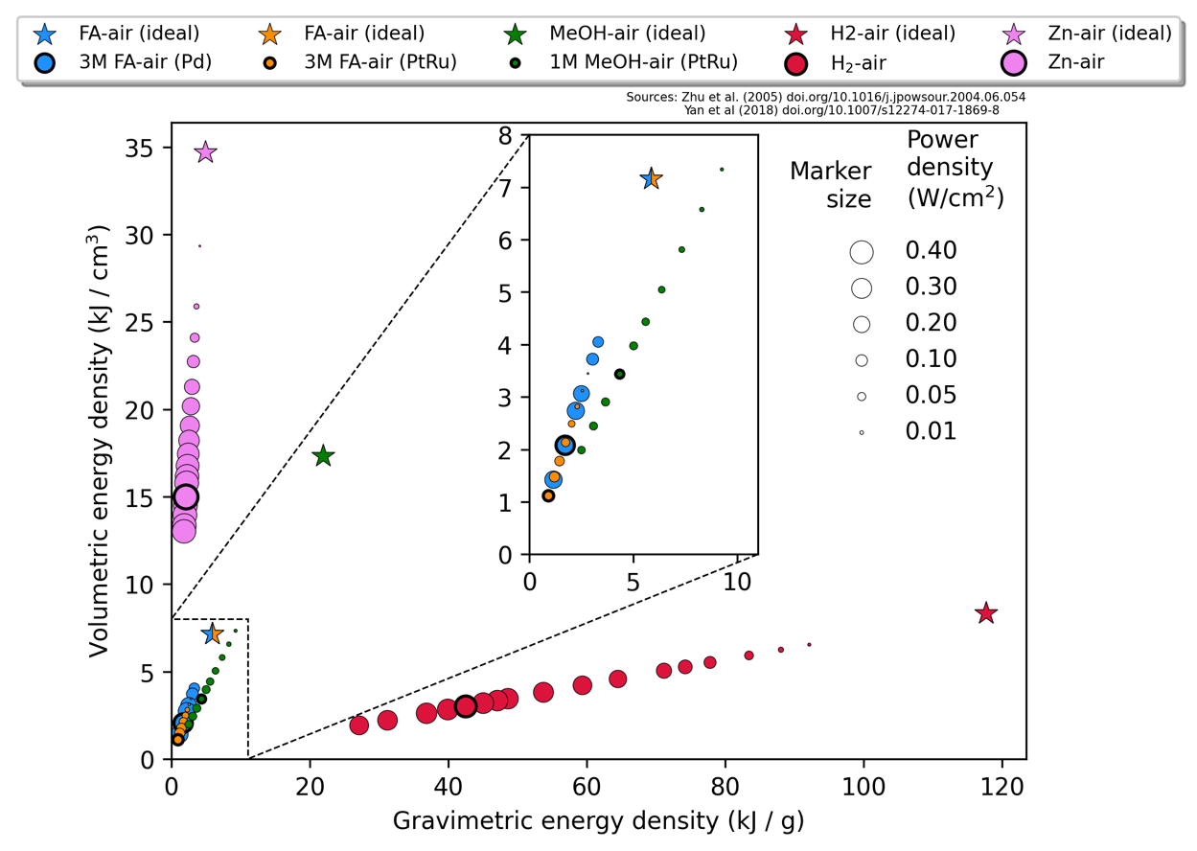

Figure 2 - Illustration of the volumetric and gravimetric energy densities as well as the power densities for formic acid, hydrogen, and methanol on different catalysts. The power density is illustrated with the marker size. The ideal catalysts are marked with stars. Illustration made by Jack Kirk Pedersen.

In figure 2, a figure made by Jack Kirk Pedersen, the gravimetric and volumetric energy densities of formic acid, hydrogen and methanol on different catalysts are compared. The power densities are shown with the marker size. As seen in the green star-shaped marker,

and as seen in the zoomed inset, formic acid has a higher power density at about the same energy densities.

Understanding and optimizing the activity of the catalyst for FAOR requires understanding the reaction pathways. Formic acid has a direct oxidation reaction (FAOR) pathway and indirect reaction pathways. In the direct FAOR pathway from FA to CO2, the two hydrogens separating CO2 and formic acid are removed one at a time with bound formate as an intermediate. In indirect FAOR pathways, bound CO is formed as an intermediate, which requires a large overpotential to oxidate to CO2. CO oxidation requires bound O or bound OH to adsorb to the surface on a neighbouring site to CO, which then participate in an oxidation reaction. Making an efficient catalyst for formic acid therefore requires a high specificity towards the direct pathway, that discourages CO from forming. If an overpotential is not applied to oxidate and remove bound CO from the anode catalyst surface, the occupied sites will be blocked, such that formate cannot bind, and formic acid cannot be oxidated, reducing the FAOR activity of the anode catalyst surface, and hence, the current. This effect has been observed experimentally, as reported in the literature14,18.

The potential should of course not smaller than the optimal $-0.17 V$, but that does not seem possible even on platinum, which binds formate very well compared to the other metals examined

as shown in figure 7, a figure from an article by Bagger et. al.,



Figure 7 - Pathways for oxidation of formic acid to carbon monoxide and carbon dioxide. The preferred direct pathway is marked with green, while the disproportionation reactions leading to carbon monoxide poisoning. The illustration is made by Bagger et. al.18.

stemming from a disproportionation reaction between bound H and bound formate, as shown in the red pathway in figure 7

In order to have an accurate and replicable reference electrode, elaborate preparation steps are described, which will produce standard electrodes with a known potential, ideally measuring a 0 V potential between standard electrodes prepared in different laboratories.

In general, the adsorption reactions will look like this:

$$AH+ * →A^{*}+\left(H^{+}+e^{-}\right)$$

And have electronic binding energies:

$$ΔE_{binding}=E_{A^{*}}-E_{AH}-E_{*}+\frac{1}{2}E_{H_{2}\left(g\right)}-e⋅U$$

Using the CHE to relate the produced proton-electron pair and the potential to the electronic binding energy. The $-e⋅U$ term relates the potential directly to the electronic binding energy, reducing the binding energy, when the potential increases. A higher potential means a lack of electrons on the catalyst electrode in question, hence a reaction that produces electrons is favoured. Similarly, a reduction reaction, that uses a proton-electron pair as a reactant is incentivized at negative potentials, where a surplus of electrons is present on that catalyst electrode. This relation between binding energies and potentials will be essential to this work.

Due to the sharpness of the Sabatier volcano, a HEA with a small fraction of sites with the optimal binding energy can surpass the activity of a surface with many near-optimal binding energies, which highlights the possible improvements with HEAs tuned to a specific reaction.